**Sunshine Coast University Hospital Tenancy AC System User Instructions**

User Instructions for the Distech

AC Control System

**BACnet Touch Screen**

**Rev 1.0**

Contents

INTRODUCTION 3

HOME PAGE 5

LOG IN 5

TYPICAL OVERVIEW 6

SET POINT PAGE 7

SET DATE / TIME 8

SET SCHEDULE 8

# INTRODUCTION

The purpose of this document is to explain how to operate the BACnet touch screen, so a user may perform the following functions

1. Adjust temperature set point
2. Start the AC unit
3. Adjust / edit schedule

The BACnet touch screen is located on the door of the control panel which is found in the plant room on the top floor.

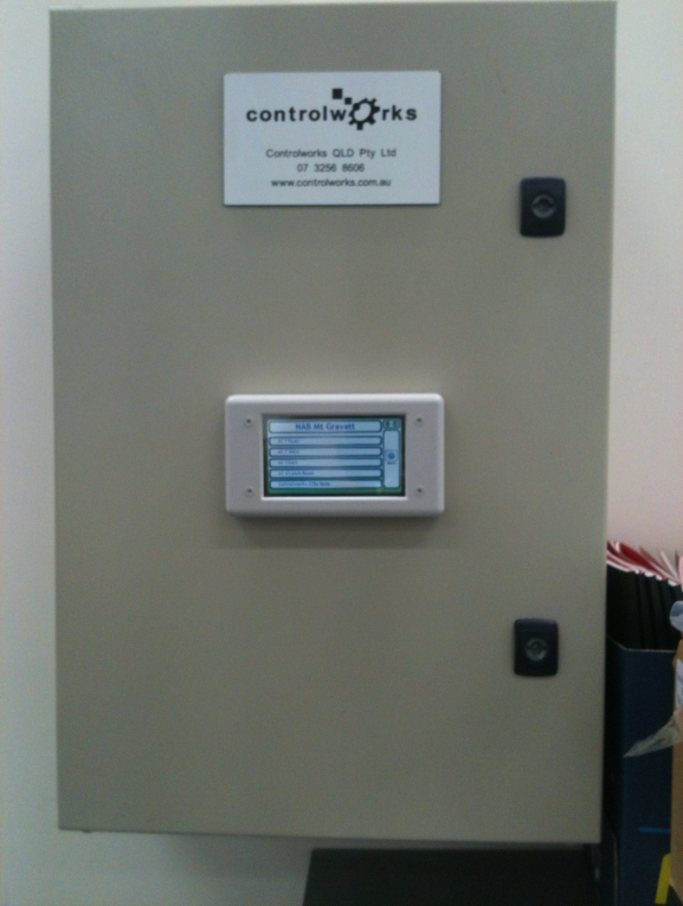

**DESCRIPTION OF OPERATION**

**MENU STRUCTURE**

The following outlines the menu structure of the display;

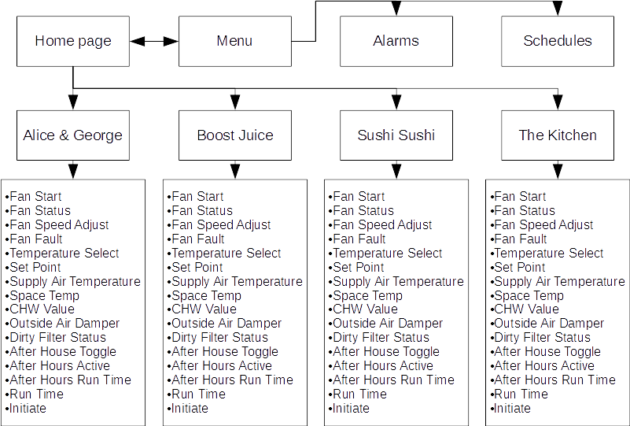

HOME PAGE

The home page links to the contact number of Controlworks and the control overview page.

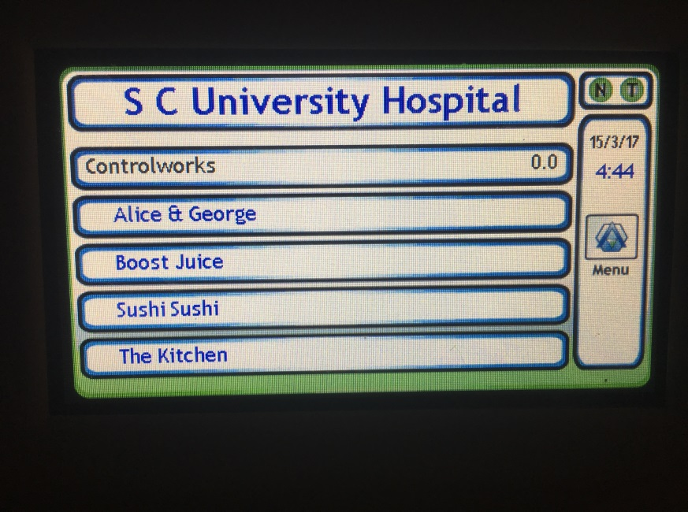

# LOG IN

In order to make any changes, the user must first log in.

The administration log in is 11111. The user log in is 12345 (this should be used to adjust temperatures, adjust run times and to start units).

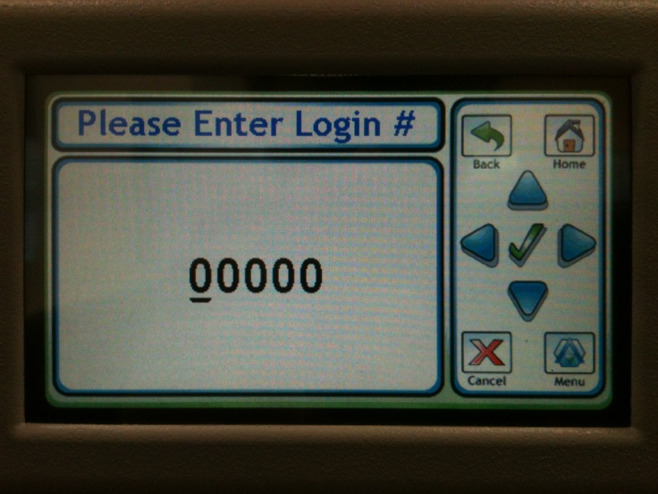

A guest user will see the following when they access a point.

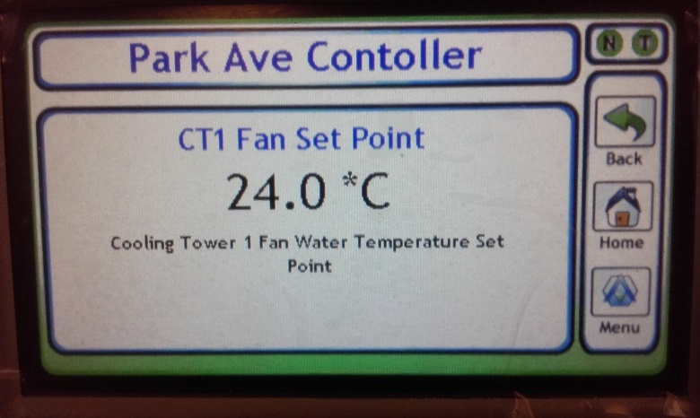

However, more detail is provided to an administrative user, as see below.

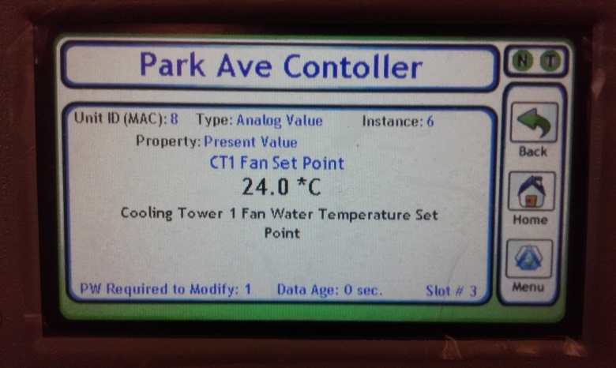

## TYPICAL OVERVIEW

The control overview is used for navigation through the major and common pages. For advanced options refer to the menu page.

**Typical Summary:** The summary pages detail the values of the associated (as seen below);

* Fan Start
* Fan Status
* Fan Speed Adjust
* Fan Fault
* Temperature Select
* Set Point
* Supply Air Temperature
* Space Temp
* CHW Value
* Outside Air Damper
* Dirty Filter Status
* After House Toggle
* After Hours Active
* After Hours Run Time
* Run Time
* Initiate

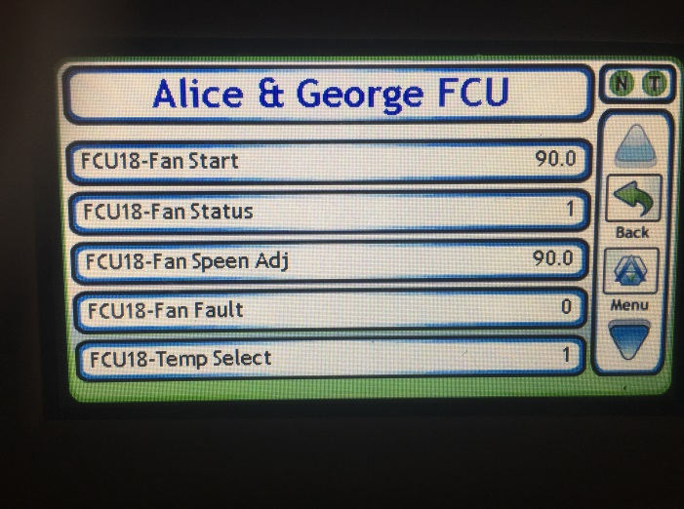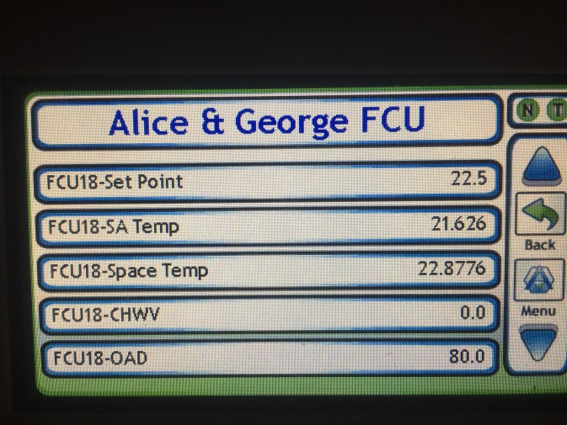

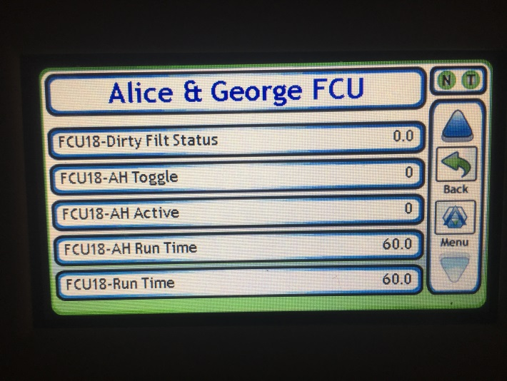 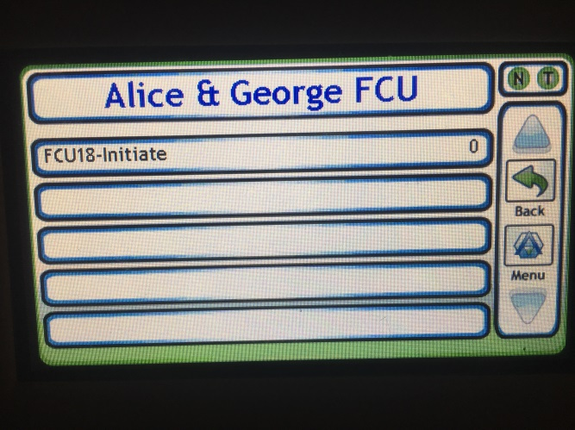

# SET POINT PAGE

From this page the user can adjust the set point and please note that you MUST be logged in with appropriate privileges.

To navigate use the left / right arrows to place the curser under the required units you wish to change, then use the up / down arrows to increase or decrease the selected units. Once happy, select the tick in the middle and you will be presented with “operation successful” splash screen, before being redirected to the original page.

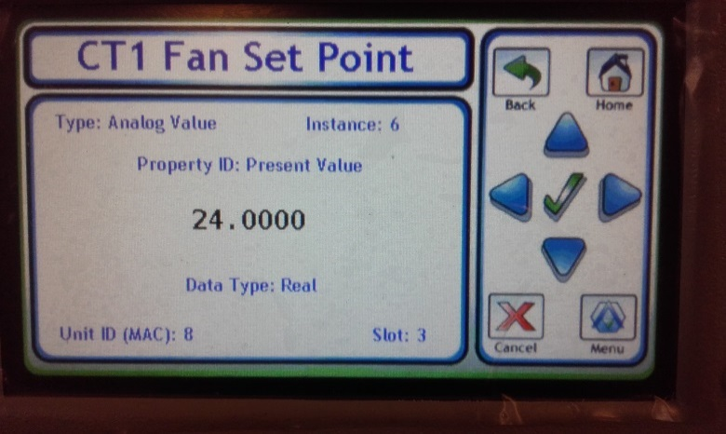

# SET DATE / TIME

To set the date and or time click to the configure button located on the menu screen. Please note, it is unlikely you will need to change this.

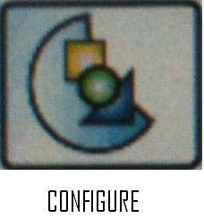

# SET SCHEDULE

To set the schedule, click on the schedule button located on the menu screen. There is only one schedule available on this site “schedule 1” select this schedule and the user can pick the day they would like to add or edit, once the day is selected the start and finish times can be adjusted.

